Optimizing and Scaling an E-Commerce Order Platform in Python

Mahesh Gaire
Basanta Ghorashainee
Sai Prasanth Chowdary Moparthi
Mayurkumar Bhavikkumar Patel
Xhon Pelushi
University of the Cumberlands
MSCS-532-M20: Algorithms and Data Structures
Course Project — Deliverable 3
Dr. Michael Solomon
July 17, 2026

Abstract
This report scales the proof-of-concept e-commerce backend from Deliverable 2 to catalogs of up to one hundred thousand products and twenty thousand orders, measures every structure against a naive baseline, and evaluates the optimizations that keep the platform fast at scale. Dynamic load-factor resizing holds hash-table lookups at 2.2 microseconds regardless of catalog size, where a fixed-capacity table degrades to 10.1 microseconds with collision chains 111 entries long. The trie answers prefix queries 45 times faster than a linear name scan at one hundred thousand products, and the pruned tree traversal answers a five-percent price-band query 5.7 times faster than a full scan. Not every asymptotic advantage survives contact with the interpreter: the pure-Python heap's O(n + k log n) top-k only ties Python's C-implemented O(n log n) sort, a constant-factor lesson measured and discussed honestly. Stress tests confirm the predicted binary-search-tree collapse under monotone insertion and the platform's graceful rejection of orders once stock exhausts. The integrated system fulfils roughly 44 thousand orders per second end to end within 65 megabytes of memory.

Introduction
Deliverable 2 established that the six data structures are correct; this phase asks whether they are fast, and stays fast as the store grows. Every experiment follows the same discipline used in the course assignments: synthetic but realistic inputs, best-of-five wall-clock timings with time.perf_counter, memory measured with tracemalloc, and a naive baseline against which each specialized structure must justify itself. The benchmark suite and its raw JSON results ship with the repository, and every figure in this report is generated directly from that data.
Scaling Strategy
Scale is produced by a dataset generator that builds catalogs of one thousand to one hundred thousand products with names drawn from an adjective-noun-variant vocabulary, so the trie faces realistic shared prefixes rather than random strings. The accompanying order stream applies a quadratic popularity skew, concentrating demand on a minority of products exactly as real stores experience, which gives the co-purchase graph hub vertices and gives the stress tests a worst-case shape rather than a uniformly diluted one. Memory is managed by design rather than afterthought: product records live once, in the catalog, and every index stores only SKU strings, so the whole hundred-thousand-product system — all six structures populated — peaks at 65 MB during its 11-second build (Figure 5).
Optimization Techniques and Their Impact
The headline optimization is the catalog's load-factor-driven resizing. With the bucket array doubling whenever occupancy exceeds 0.75, expected chain length stays constant and measured lookups are flat at about 2.2 µs from one thousand to one hundred thousand products. The Phase 2 fallback configuration with a fixed 1,024-bucket array — the classic under-provisioned table — degrades linearly to 10.1 µs per lookup with maximum chains of 111 entries (Figure 1), the O(n/m) behavior chained hashing predicts (Cormen et al., 2022). Alternatives such as cuckoo hashing would bound the worst-case probe count as well, at the cost of insert-time rebuilds (Pagh & Rodler, 2004); for a read-heavy catalog the resizing chained table is the better trade.
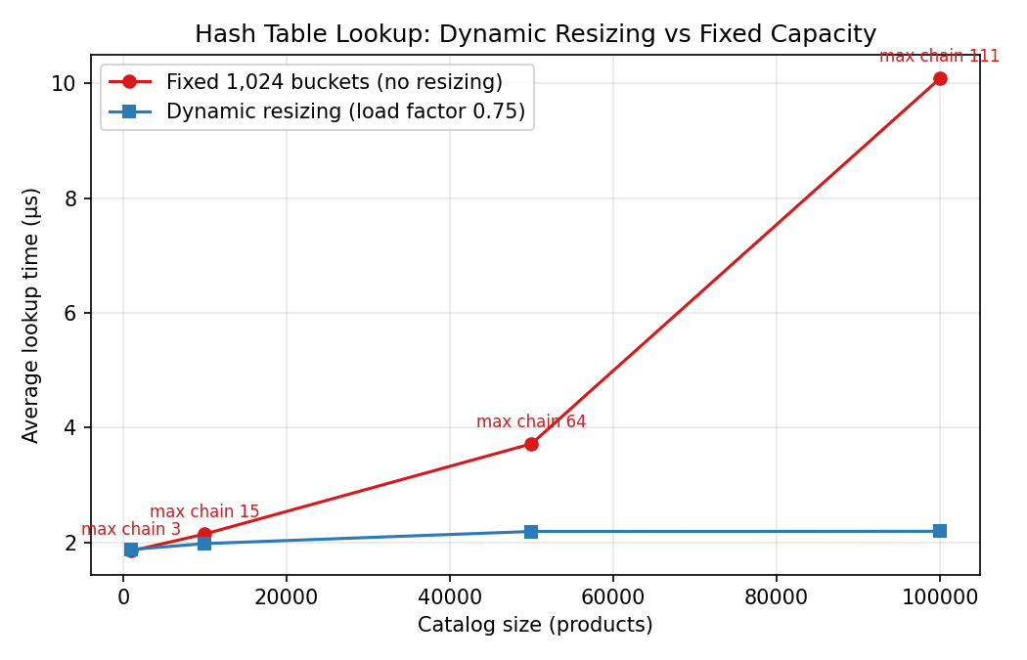
Figure 1. Hash-table lookups: dynamic resizing stays flat while fixed capacity degrades linearly.
Search shows the largest asymptotic payoff. A linear scan touches every name on every keystroke and reaches 82 ms per query at full scale, while the trie's prefix walk (Fredkin, 1960) answers in 1.83 ms — a 45-fold advantage that widens with catalog size (Figure 2, log scale). The price index shows the same pattern in milder form: the pruned in-order traversal answers a $100–$125 query returning 5,040 products in 1.2 ms against 6.9 ms for scanning and sorting, a 5.7-fold advantage that grows with the fraction of the catalog outside the queried band (Figure 3).
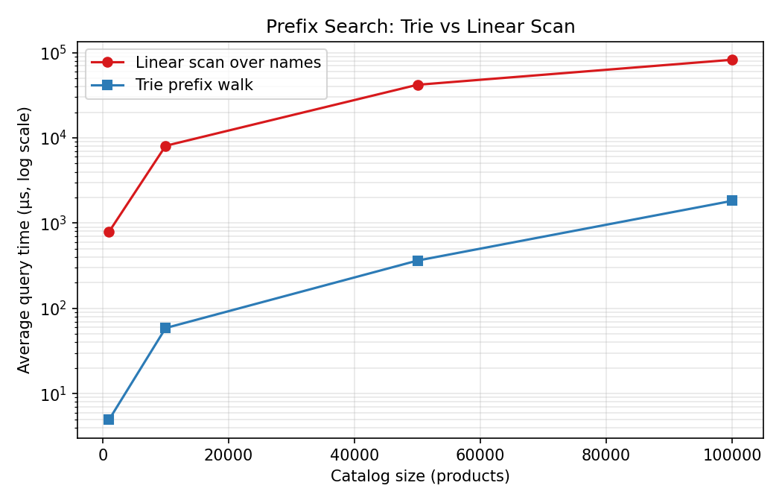
Figure 2. Prefix search, log scale: the trie's advantage grows with catalog size.
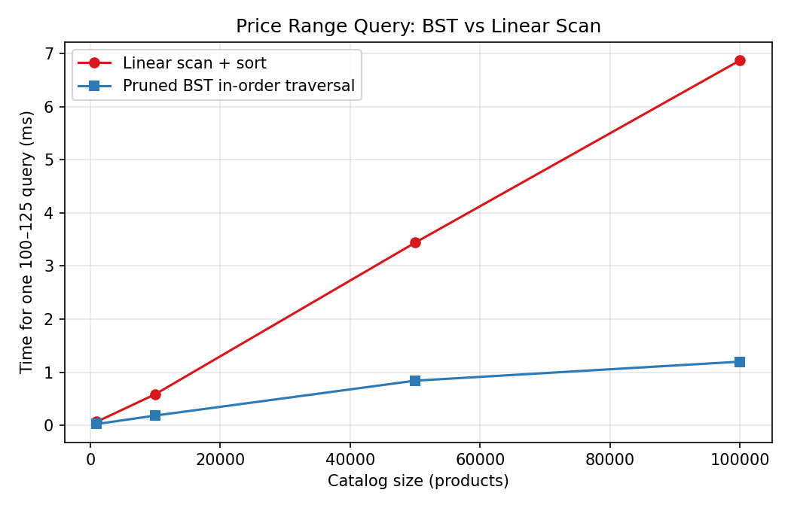
Figure 3. Price-band query: pruned BST traversal vs linear scan.
One optimization refused to pay, and the honest finding is worth more than a flattering one. The heap answers top-10 queries in O(n + k log n) — asymptotically better than fully sorting n counts in O(n log n) (Knuth, 1998) — yet at every measured size the pure-Python heap (76 ms at n = 100,000) merely ties Python's built-in sort (74 ms), because Timsort executes in C while every sift-down comparison of the heap executes in the interpreter (Figure 4). The lesson is that constant factors set by the execution environment can consume an asymptotic advantage at practical scales; the heap's true value in this platform is supporting incremental updates without re-sorting, not raw throughput on a cold ranking.
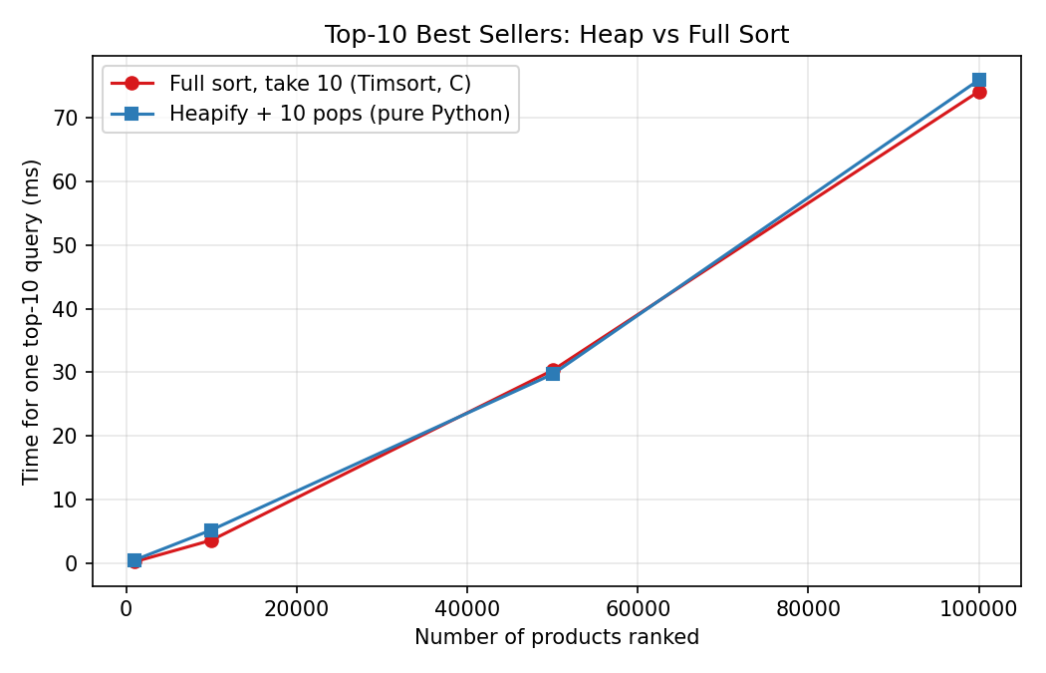
Figure 4. Top-10 ranking: the pure-Python heap ties, but does not beat, the C-implemented sort.
Advanced Testing and Validation
Two stress tests probe the platform's known weak points. First, the unbalanced price tree was loaded with strictly increasing prices, its documented worst case: four thousand monotone insertions produce a tree of height 4,000 versus 25 for the same prices inserted in random order, and the build cost rises to 0.40 seconds as each insertion walks the full right spine (Figure 6). Query times on the degenerate tree remain acceptable only because the traversal is iterative — a recursive walk would overflow Python's stack — validating that Phase 2 design decision. Second, the twenty-thousand-order stream was replayed against a one-thousand-product catalog so that demand deliberately exhausts supply: 9,413 orders were rejected by the atomic out-of-stock check without corrupting any line item's stock, while the same stream against the full catalog rejects only 234. Throughput declines modestly with catalog size (Figure 5) because fulfilment itself is O(1) per order; the decline reflects colder caches, not algorithmic growth.
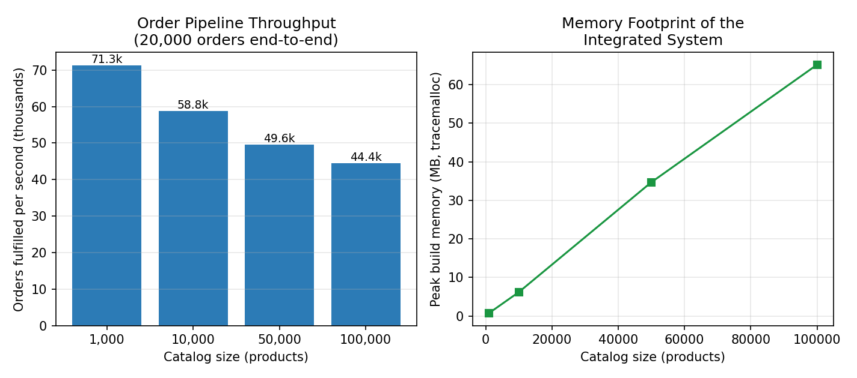
Figure 5. End-to-end throughput and memory of the integrated system.
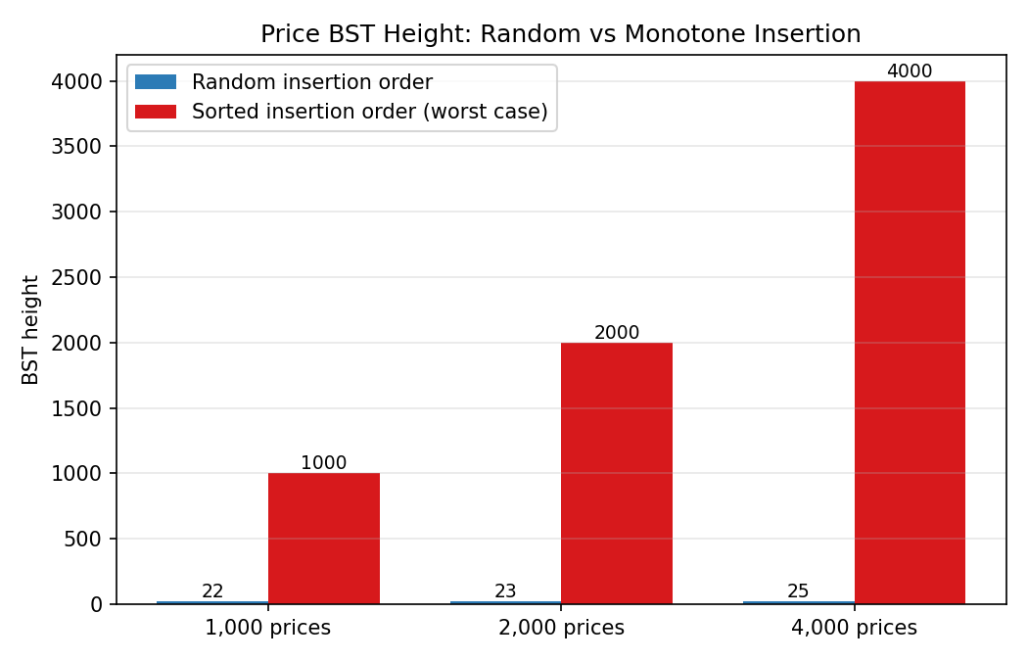
Figure 6. BST height under random vs monotone insertion: the predicted degeneration, measured.
Performance Analysis Against the Proof of Concept
Operation (n = 100,000) | Naive / PoC baseline | Optimized | Gain
Catalog lookup | 10.1 µs (fixed 1,024 buckets) | 2.2 µs (resizing) | 4.6×
Prefix search | 82.4 ms (linear scan) | 1.83 ms (trie) | 45×
Price-band query | 6.9 ms (scan + sort) | 1.2 ms (pruned BST) | 5.7×
Top-10 ranking | 74 ms (full sort) | 76 ms (heap) | ≈1× (tie)
Order fulfilment | — | 44,422 orders/s end to end | —
Table 1 condenses the comparison. Three of the four specialized structures repay their complexity with multiplicative gains that grow with catalog size; the fourth ties its baseline and is retained for its incremental-update behavior. These are exactly the trades a production storefront makes, and they were verified here by measurement rather than assumed from asymptotics.
Final Evaluation
The optimized platform meets its scaling goal: every customer-facing query is answered in low single-digit milliseconds at one hundred thousand products, and the fulfilment pipeline sustains tens of thousands of orders per second in a single interpreter thread. The measured limitations are equally clear. The price tree needs self-balancing (AVL or red-black rotation) before it can accept sorted bulk loads; the co-purchase graph grows without bound and would need edge decay in long-lived deployments; and any component on Python's critical path pays interpreter constants, as the heap experiment demonstrates. Each limitation is localized behind the facade, so all three remediations are future refinements rather than redesigns.

References
Cormen, T. H., Leiserson, C. E., Rivest, R. L., & Stein, C. (2022). Introduction to algorithms (4th ed.). MIT Press.
Fredkin, E. (1960). Trie memory. Communications of the ACM, 3(9), 490–499. https://doi.org/10.1145/367390.367400
Knuth, D. E. (1998). The art of computer programming: Vol. 3. Sorting and searching (2nd ed.). Addison-Wesley.
Pagh, R., & Rodler, F. F. (2004). Cuckoo hashing. Journal of Algorithms, 51(2), 122–144. https://doi.org/10.1016/j.jalgor.2003.12.002

